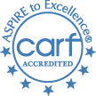
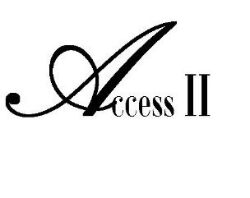
Your “Access II” disABILITY Resources
Independent Living Center
2016 Volume 73
Enabling News
Activity Spotlight
Disability Legislative Day In Jefferson City

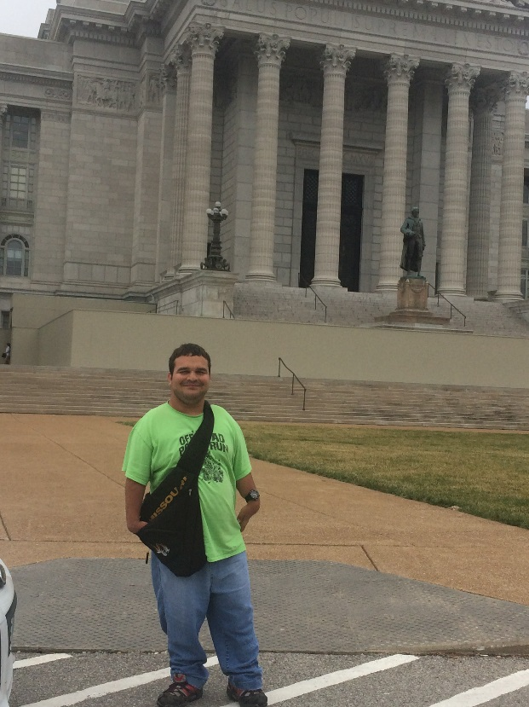
On March 10, 2016 Access II as well as some of our consumers participated in the Disability Legislative Day at the Capitol in Jefferson City, Missouri. March 10th was a crucial day for all Disability Rights advocates in Missouri to participate in Disability Rights Legislative Day. This is a vital call to action because of Senate Bill 925 (SB925) which, if passed, will provide more opportunities for people with disabilities to work and still retain necessary services such as personal attendant care. During this time we were able to walk around the Capitol talking to local representatives and senators about our programs. Pictured to the right is Noah, from Chillicothe, Missouri. He came to Access II as a Money Follows Person (MFP) Transition. By transitioning, Noah has met his ultimate goal by living independently in his own apartment!
What We’ve Been Doing
Polar Plunge
In February, Access II took the plunge to jump in to freezing cold water to raise money for the Special Olympics Team. Access II was able to raise $1,200 for this year’s event. This year’s Polar Plunge at Lake Viking had a total of 13 teams participate raising a grand total of $29,836!!
Second Grade Learning Day
Access II was honored to host students from Gallatin Elementary School, May 12th for Second Grade Learning Day. The students took part in wheelchair races, learned some sign language and participated in a tactile demonstration. They heard a story about accepting others and received a lesson on hand washing from the Germ Doctor. A picnic was served and some brave volunteers participated in a "Blind Lunch" while their classmates assisted. Second Grade Learning Day is a disability awareness event presented by Access II for local schools. The goal is to show some of the everyday challenges of living with a disability. Access II's staff work to ensure the children have fun while learning and gaining empathy for people living with those challenges.
For information on Second Grade Learning Day please contact Lisa Bowles 660-663-2423 ext. 230
Coming Up
Helping Hands Committee
Would you like some help picking up your yard, planting flowers, or organizing your closet? These are just some of the tasks the Helping Hands Committee at Access II would be pleased to assist you with! We understand that you may have small projects around the house that need to be addressed but are not on your plan of care. If you could use a helping hand please contact Jessica Adkins with the Helping Hands Committee at 660-663-2423 ext. 231 and request an application be mailed to you. All needed items must be supplied by the consumer and all requests must be approved by the committee. We will be headed to Chillicothe this month and your project could be next!

5K Color Run/Walk Event

Access II Independent Living Center will hold its annual 5K Color Run/Walk fundraiser event on Saturday, May 21st in Gallatin. All proceeds benefit Access II’s special projects for individuals with disabilities in our community.
Registration is $50; ages 13 and under is $35. Participants can also register on the day of the event. In the event of inclement weather the 5K will be rescheduled for Saturday, June 4th. Please view the Access II Facebook page in this event.
Registration and check-in starts at 8:30 a.m. on race day at the southwest corner of Market and Grand Streets. The race begins at 9:00 a.m. Individuals using wheelchairs can compete individually or with the assistance of a team of two pushers for one registration fee. There are 3 ways to register: 1. online at Eventbrite.com 2. Visit our website at www.accessii.org or 3. Call us at 888-663-2423 or email us at access@accessii.org to have a registration form mailed to you. We hope to see you there!

Summer CIL PETS Program
Access II staff will be busy this summer working with local high school students on employment and independent living (IL) skills. This year Access II has partnered with Polo High School and Pattonsburg High School to put on the CIL PETS (Centers for Independent Living Pre Employment Transition Services) program. The program is targeted at high school students ages 16-24 with a disability who will be returning to school in the fall. Students will work side by side with Access II staff on employment skills such as resume writing and interviewing preparation. They will also work on developing Independent Living skills such as cooking, laundry, and budgeting, and drivers education. The goal of the program is to increase employment outcomes for youth with disabilities and give them the knowledge and skills to transition out of high school successfully. For more information on this program please contact Jessica Adkins or Lisa Bowles at 660-663-2423 ext. 231 or ext. 230.
What’s New
Driver’s Education Course
A new class Access II is now offering is a training course for the written exam for the driver’s permit. This course will entail one on one training with our staff to help ensure you are ready to score big with your upcoming driver’s permit test. For more information please contact Jessica Adkins at (660) 663-2423 ext. 231 or Lisa Bowles (660) 663-2423 ext. 230

“ACCESS II” BETTER HEALTH AND WELLNESS THROUGH MEDICARE SERVICES
Medicare covers a wide array of preventive services to help you stay healthy. Preventive services include various exams, lab tests and screenings that help find health problems in their earliest stages when they're easier to treat. They also include a number of vaccinations and programs for health monitoring, as well as counseling and education to help you take care of your own health. If you are receiving Medicare or know someone who is, call today and speak to a certified CLAIM counselor. A certified CLAIM counselor is trained to answer your Medicare questions and ensure you are receiving all the Medicare services available to you. All Medicare CLAIM counselor services are confidential and free of charge. Let’s make 2016 as healthy as we can be by taking advantage of Medicare prevention and wellness services. Call today for your one on one free Medicare counseling appointment.
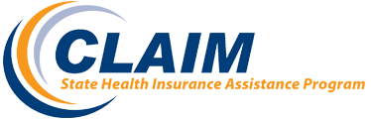
Certified CLAIM counselor
Marina Beebe
1-660-663-2423 EXT 229
Check out our website at www.accessii.org ~ We will be undergoing changes!

BOARD
President
Annie Gibson
Vice President
James Ross
Secretary
Leslie Stanley
Treasurer
David Arnold
MEMBERS
Tim Tadlock
Stacey Maxwell

Find us on:

STAFF
Executive Director
Heather Swymeler
Financial Director
Amber Wells
Program Manager
Brandy Gannan
Benefits Specialist/ILS/TAP
Marina Beebe
Employment Specialist/ILS
Jessica Adkins
In-Home Director
Dawn Litton
LPN
Samantha Brewer
CDS Case Mgr. /ILS
Jen Miller
CDS Payroll Specialist
Staci Hamilton
ILS/Child Advocate/Transitions
Lisa Bowles
ILS/Intake Specialist
Chelsea Rector
CALENDAR OF EVENTS
MAY
19 STAFF Meeting – Center Closed
21 5K Color Run/Walk
30 Memorial Day – Center Closed

JUNE
16 STAFF Meeting – Center Closed

Office Hours
8 a.m. – 4:30 p.m.
Monday-Friday

Access II, Independent Living Center
101 Industrial Parkway
Gallatin, MO 64640

